**Introducing the**

**Collaboration Zone**

**@ your library**

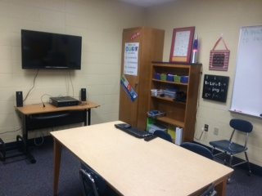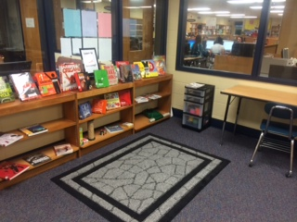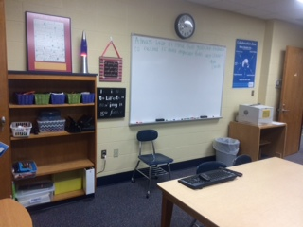

Whiteboard and supplies like scissors, markers, colored pencils, and glue guns

Makerspace with craft supplies. This month it’s Duct Tape! 25 colored rolls, books with patterns, a cutting board etc..

40 inch TV

Attached to a computer with network and Internet access. Can connect to a laptop, surface or other devices.

**Available to both students and staff.**

**Practice Presentations**

**Collaborative Work**

**Data Teams**

**Enrichment**

**Intervention/**

**Remediation**

**Meetings**

**Sign Up in the Library Office**